PIZZA SALES SQL QUERIES

KPI
- Total Revenue
SELECT SUM(total_price) as Total_Revenue
FROM pizza_sales
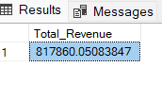
- Average Order Value
SELECT SUM(total_price)/COUNT(DISTINCT order_id) as Average_Order_value
FROM pizza_sales
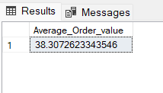

- Total Pizzas Sold
SELECT SUM(quantity) as Total_Pizzas_Sold
FROM pizza_sales
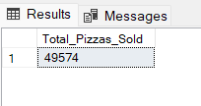

- Total Orders
SELECT COUNT(DISTINCT order_id) as Total_Orders
FROM pizza_sales
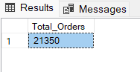
- Average Pizzas Per Order
SELECT CAST(CAST(SUM(quantity) AS DECIMAL(10,2))/CAST(COUNT(DISTINCT order_id) AS DECIMAL(10,2)) AS DECIMAL(10,2)) as Average_Pizzas_Per_Order
FROM pizza_sales
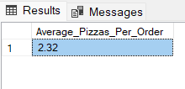

--Daily Trend
SELECT DATENAME(DW, order_date) as order_day, COUNT(DISTINCT order_id) as total_orders
FROM pizza_sales
GROUP BY DATENAME(DW, order_date)
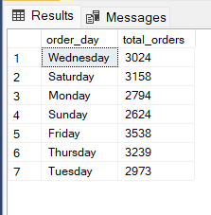

--Hourly Trend
SELECT DATEPART(HOUR, order_time) as order_hours, COUNT(DISTINCT order_id) as total_orders
FROM pizza_sales
GROUP BY DATEPART(HOUR, order_time)
ORDER BY order_hours
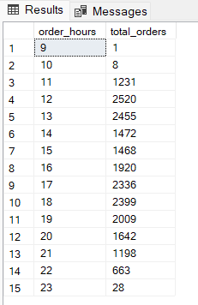

--Sales Percentage by Pizza Category
SELECT pizza_category, CAST(SUM(total_price)*100/(SELECT SUM(total_price) FROM pizza_sales WHERE MONTH(order_date) = 1) AS DECIMAL(10,2)) as sales_percentage_by_category
FROM pizza_sales
WHERE MONTH(order_date) = 1
GROUP BY pizza_category
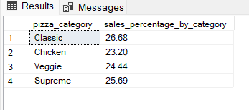

--Sale Percentage by Pizza Size
SELECT pizza_size, CAST(SUM(total_price)*100/(SELECT SUM(total_price) FROM pizza_sales WHERE DATEPART(quarter, order_date)=1) AS DECIMAL(10,2)) as sales_percentage_by_size
FROM pizza_sales
WHERE DATEPART(quarter, order_date)=1
GROUP BY pizza_size
ORDER BY 2 DESC

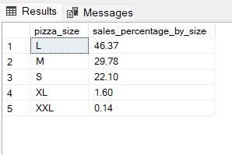

--Total Pizza Sold by Pizza Category
SELECT pizza_category, SUM(quantity) AS total_pizza_by_category
FROM pizza_sales
GROUP BY pizza_category
ORDER BY 2 DESC
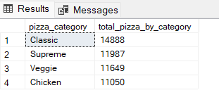

--Top 5 Best Seller by Total Pizza Sold
SELECT TOP 5 pizza_name, SUM(quantity) as total_pizza_sold
FROM pizza_sales
GROUP BY pizza_name
ORDER BY 2 DESC
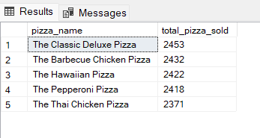

--Bottom 5 Best Seller by Total Pizza Sold
SELECT TOP 5 pizza_name, SUM(quantity) as total_pizza_sold
FROM pizza_sales
GROUP BY pizza_name
ORDER BY 2 ASC
